PRACTICAL 7
7A. Memory Layout (Code, Global, Static, Heap, Stack)
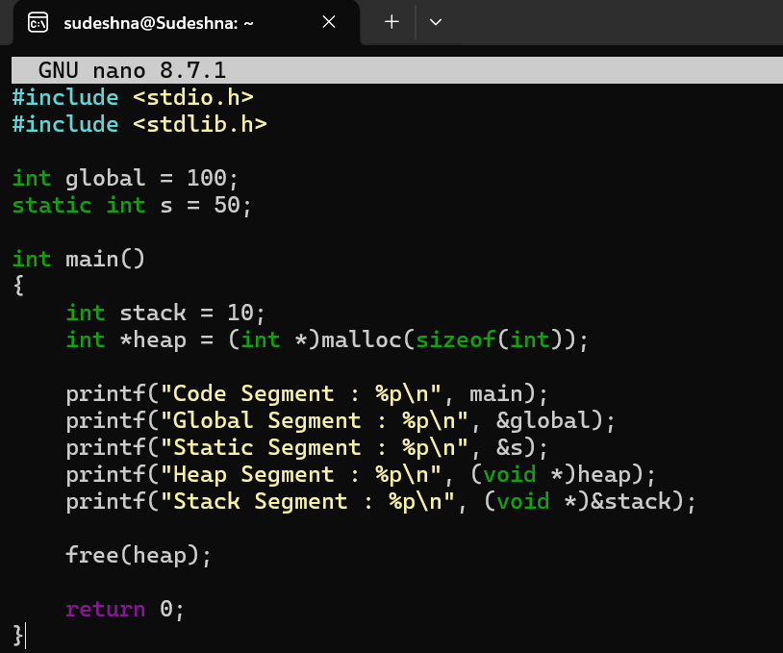
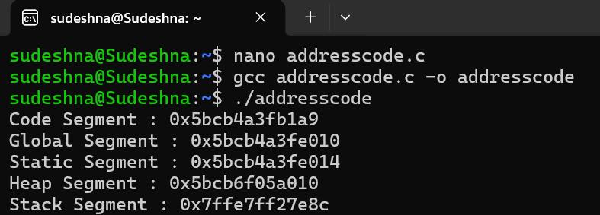
7B. /proc/maps
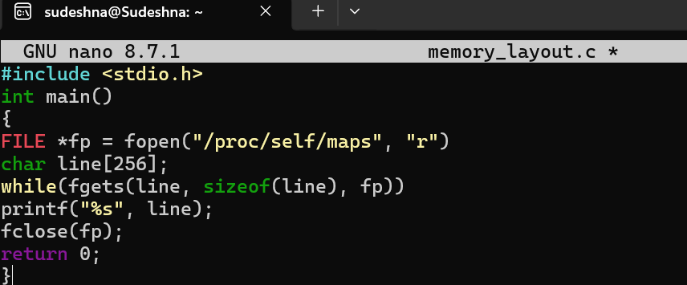
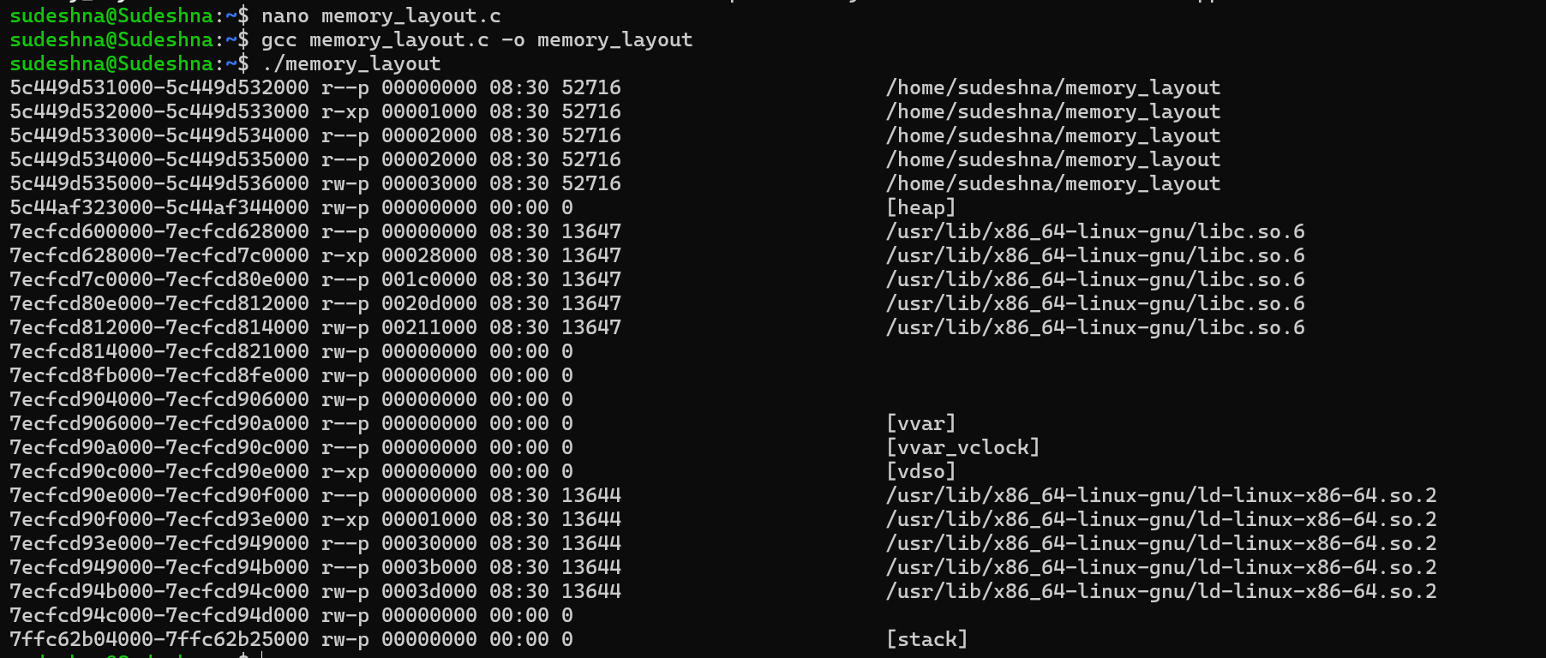

PRACTICAL 8
8A. malloc(), calloc(), realloc(), free()
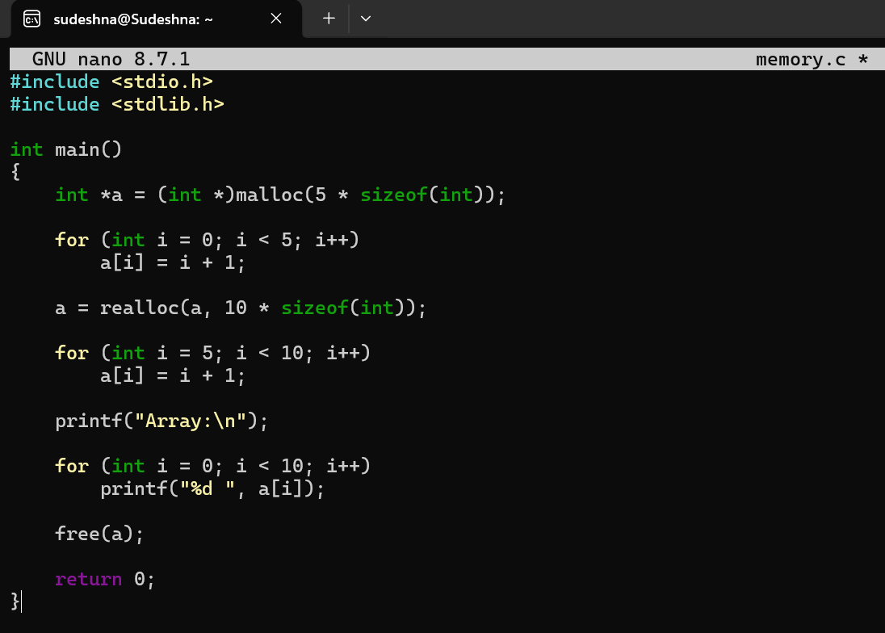
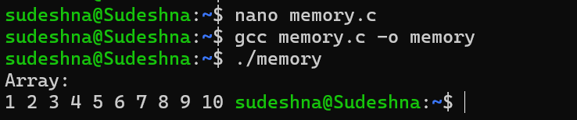
8B. malloc(), calloc(), realloc(), free()
